

Introduction to Myofascial Release

Suzanne Blizzard, OTRL

Owner/Therapist

1106 N Beeline Hwy

Payson, AZ 85541

928.978.7426

www.kokopellimfr.com

Myofascial Release is becoming more mainstream with articles about fascia showing up in popular magazines, the use of foam rolling in the gym, and many manual techniques similar to Myofascial release claiming to reduce stiffness and pain in the muscular system. Many who foam roll or get deep tissue massage are hoping that these activities will reduce pain and increase range of motion but find that it does not last for more than a few hours or, at the most, a day or two. At Kokopelli Myofascial Release I exclusively use the John Barnes Myofascial Release Approach (MFR) because it is the most effective method for long lasting results and authentic healing. This method yields changes in the body that create an environment for the cells of the body to function to the best of their ability. Myofascial Release (MFR) will significantly reduce or eliminate pain, improve range of motion throughout the body, and create an environment for the release of trauma from the body. Let’s look at the system that MFR works with in order to get these long lasting results.

The fascia of the body was once thought of as nothing more than a covering for the muscles and organs. It had no known purpose aside from organizing the body into parts. We now know that there are several different types of fascia in the body having a purpose and acting as a communications system not unlike the fiber optic system of our internet today. In fact it is a multidimensional web throughout the body, from the top of our heads to the tips of our toes, front to back, side to side and throughout the body without interruption.

Fascia accounts for most of the water content in our body. It can feel like a thick liquid like the clear, slimy substance under the chicken skin, or can be as hard as bone (in fact, bone is mineralized fascia!) and thick like the silver covering on a rack of ribs. It is also in the cell itself. Consider a hardboiled chicken egg. It is one cell, a giant cell! The film under the shell is fascia and the thin film surrounding the yolk is also fascia! In this way, the cells of the body, no matter how far apart they are, can communicate with each other at 20,000 times the speed of light.

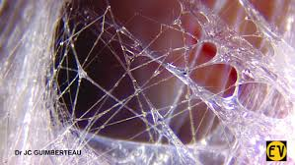

Fascia is like a web. There is clear fluid surrounding the more gel like microtubules and microfibrils of the fascia in this picture. These strings of fascia glide rather than stretch. The fascial system is a glide system.

Fascia is the multidimensional container of the subconscious and our mind. It is our shock absorber and our memory keeper. Coupled with the sensory systems of smell, hearing, taste, sight and touch, the fascia stores memories that may be repressed until that area of the body is treated. When inflammation is thwarted by the use of analgesics and anti-inflammatory medications, the body is paused or suspended in the process creating conditions we label as disease, syndrome, or chronic pain. Fascial restrictions develop from trauma, surgery and the inflammatory process. These restrictions can exert over 2000 lbs per square inch on the system. Is it any wonder the low back, hips and shoulders cannot withstand the pressure and we “pop a disc” or get bursitis? Only with gentle pressure and time can we soften the straightjacket of fascial restriction and regain full function and mobility of the body.

Think of the body as a sponge. When you buy it from the store it is packaged and somehow slightly damp enough that it is pliable. Once used however, it begins to dry out and become hard between uses. MFR gently rehydrates the fascia which then, like the sponge, soaks up the available fluid to become softer and more pliable. Hence it is important to replace fluids after a treatment. The “sponge” is no longer dry and can move with the forces exerted on it without breaking or putting undue pressure on the adjacent structures such as joints.

How do these restrictions form? It appears that fascial restrictions can begin as early as while we are still in the womb. The process of birth increases the likelihood of additional fascial restrictions. As we grow and experience all that life brings our way from falling while learning to walk to the death of a beloved pet, traumas are absorbed into the fascia to be dealt with at a later date when the body can process this trauma. The Fight, Flight or Freeze alarm system is activated as a life saving measure, but unlike our animal counterparts, we as humans get embarrassed, angry or check out altogether and don’t take the time to literally shake and burn off the excess energy and adrenaline that was needed at that time. This gets solidified in the fascia and over time causes literal restrictions. I have come to realize that often we may not think that an incident may have been traumatic, but the body may have perceived it as such. Therefore, the MFR therapist moves slowly and deliberately so as not to alarm or activate the body if at all possible. There is also a level of trust that needs to occur in order for this treatment to be effective. I have worked with patients with abuse backgrounds and the most effective use of self is my ability to create a safe space physically as well as psychologically.

So what is MFR? There are many types of manual therapies that could be considered Myofascial Release; however, they generally have one thing in common, additional pain and the possibility of lasting damage from the aggressiveness of the techniques. The John Barnes Myofascial Release Approach philosophy is based on very specific elements of the fascial system. It is gentle and individualized to the patient participating in the treatment process. The therapist applies pressure on the skin to the depth the patient can tolerate then waits for 5 minutes. Time and pressure are the keys to this treatment process. One must be patient in order for MFR to be effective. The patient is asked to get a picture in their mind of melting butter or stretching taffy. The fascia responds by softening and as the fascia begins to move and glide, the therapist’s hands will maintain the pressure and move with the fascia ensuring the patient receives a full, healing release. Once the fascia in an area has been released, the therapist moves on to other areas that need treatment. This is a whole body treatment. There is a saying within the MFR Tribe that goes: “Find the pain, look elsewhere for the cause.” This alludes to the multidimensional web feature of fascia. You may come to me due to back pain, or leg pain, but that is the end result of the fascial restriction! I need to locate the restriction at the other end as well to treat the entire cause of the pain, not just the symptoms. There is a good possibility that during the treatment of your hip, you might feel your sinuses drain! I had a client say she could feel her brain move while I was gently pulling on her legs the fascial restrictions were so tight and tangled.

Treatment is performed with the patient clothed in shorts and a tank top. This allows me to have access to the skin for the treatment process, but also so I can see the skin. At times the fascia will actually cause an area of the skin to turn red. This indicates that it is an area that requires treatment. Other indications that the body needs treatment in an area is where the skin “blanches” or turns bright white, lines in the skin, lack of skin movement over the underlying tissues or the patient will comment on a sensation.

“How many treatments do I need to get better?” is often the third or fourth question that is asked. The answer is, that depends. It depends on your goals. It depends on how much of your life you want to change. It depends on if you have the courage to withstand the healing crisis. The healing crisis is variable and dependent on the person. It is the reaction your body has to the treatment. Some of the ways a healing crisis is expressed is through pain, crying, headaches, nausea, emotional outbursts including anger or irritability. It can last for 12 to 48 hours during which your body and mind are changing for the better. They are healing! So many people have pain that drives them to seek treatment. However; once they begin treatment, they find that other areas of their life change for the better. Some are able to go off of medications; others begin to eat differently, allowing them to shed pounds and improve their mobility; and others seem to have such profound changes that they change their job, develop healthy boundaries and/or leave relationships that were not to their best interest. We become the best version of ourselves along the way.

A client once said, “What gets released stays released!” MFR is authentic healing. It may not seem like it at first; after all, many of my patients have been developing fascial restrictions for 60 plus years! And there can be a healing crisis which may make you feel uncomfortable for a time. But as you continue with treatment, self treat at home, and listen to your body, you will experience the results you had hoped for at the beginning of your journey. You may also find that your thinking changes as you release trauma. You may have a greater awareness of yourself leading to choices that were not available to you previously. “Without awareness there is no choice!” MFR gives you choices.

A Sample of Treatment Techniques

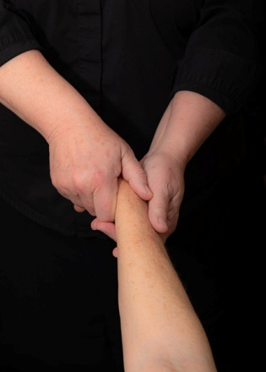

**Arm Pull**- Gently pulling on the arm can reach up into the shoulder and neck. Some patients can feel it into their head!

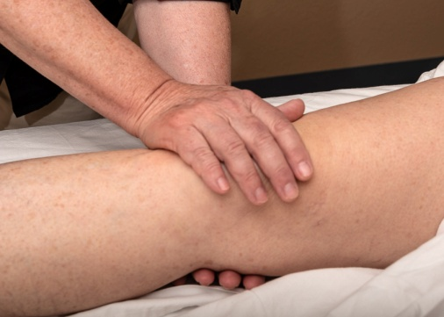

**Transverse Hold**- Gently applying pressure above and below the body allows the fascia to melt without undue pressure on the skeletal system. Great for individuals with Osteoporosis!

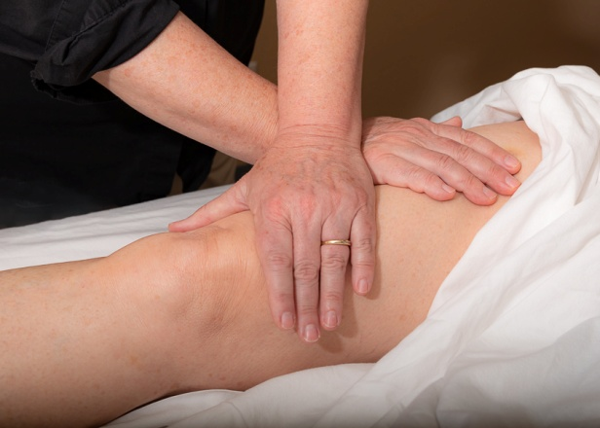

**Cross Hand Release**- This technique is the work horse of the treatment process. It is used almost everywhere on the body to gently and efficiently apply pressure to the fascia.